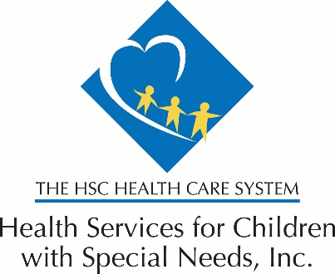

March 17, 2020

Re: Pharmacy Access during COVID-19 Containment Activities

Dear Providers:

As efforts to limit community spread of the coronavirus disease 2019 (COVID-19) continue in the region, Health Services for Children with Special Needs, Inc. (HSCSN) wants to provide an update regarding pharmacy access for our enrollees, your patients.

Extra fill at Retail Pharmacies
HSCSN has authorized our Pharmacy Benefit Manager, CVS Caremark, to provide an extra fill (30-days for retail pharmacies) when requested by the enrollee. This allows enrollees to “stock-up” so they do not run out of medication(s) during travel restrictions. Enrollees must have a valid prescription in place to use this optional benefit.

Mail Order Service
Enrollees may obtain medications via the CVS Caremark Mail Order Service. The enrollee or caregiver can initiate a switch to Mail Order by calling CVS Caremark Customer Care at 1-866-885-4944. Enrollees can also initiate Mail Order Service by requesting their prescriber to submit a 90-day prescription to the Mail Order Pharmacy (either by phone or fax).

CVS Caremark Phone Numbers
CVS Caremark Customer Care 1-866-885-4944
CVS Mail Order Pharmacy 1-800-875-0867
CVS Specialty Pharmacy 1-800-237-2767, Fax 1-800-323-2445, or www.CVSspecialty.com

Questions
If you have questions related to this notice, please contact the HSCSN Provider Relations Department at 202-467-2737. For more information about HSCSN’s response to COVID-19, visit https://hscsnhealthplan.org/coronavirus.

For more information visit: hscsnhealthplan.org.
For reasonable accommodations, please call (202) 467-2737.
